Case 1 – product search – Edge browser

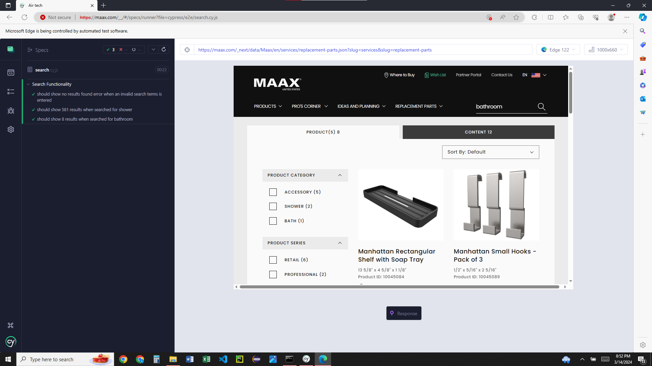

Case 2 – where to buy – Edge browser

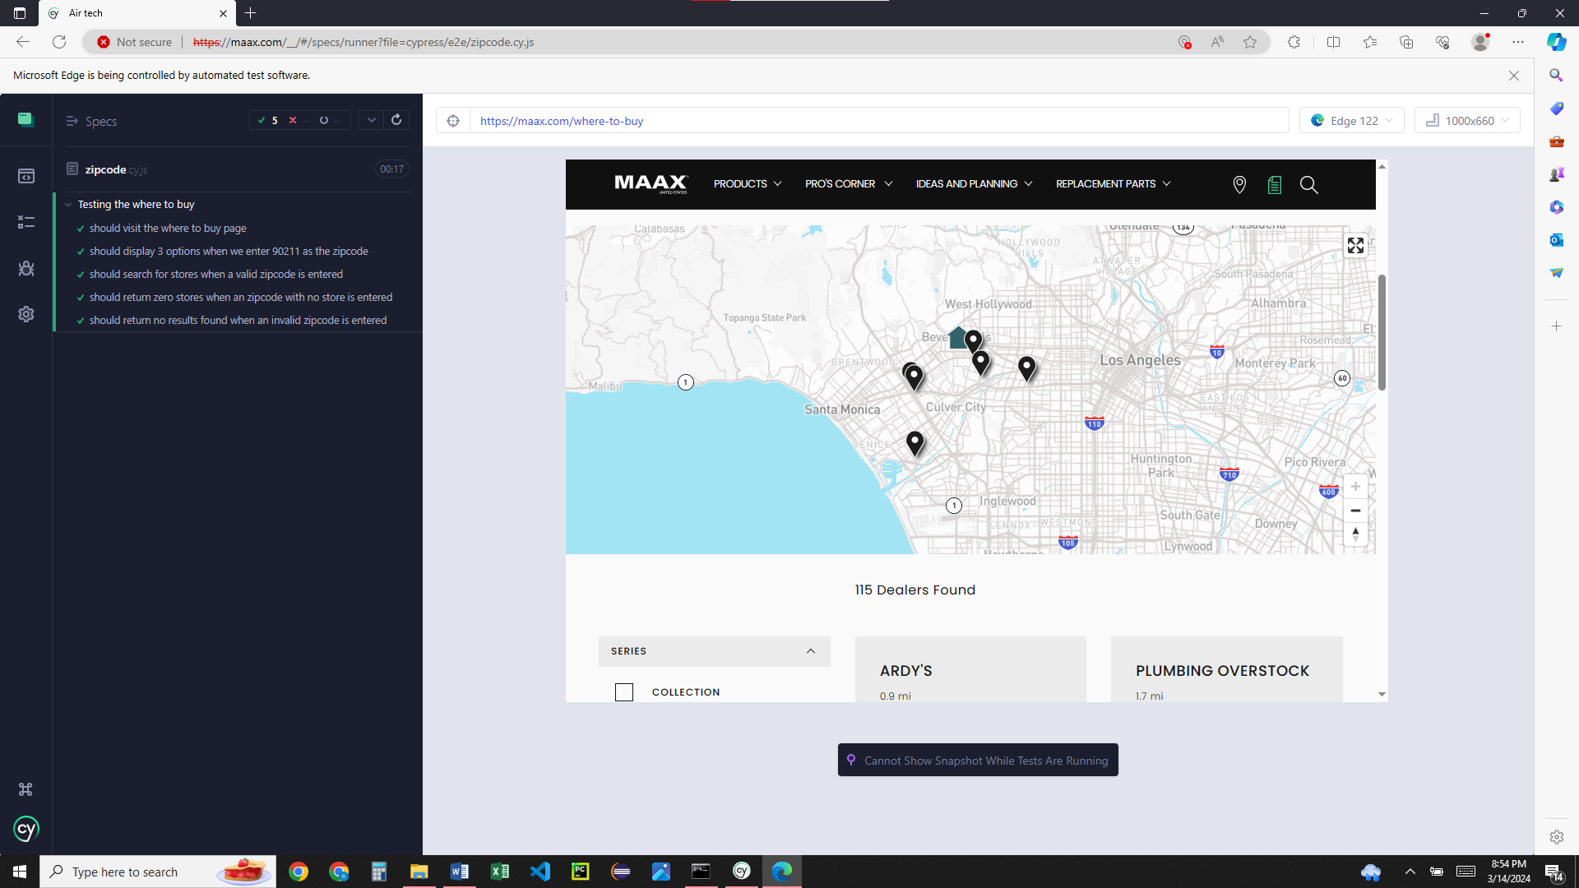

Case 1 – product search – Chrome browser

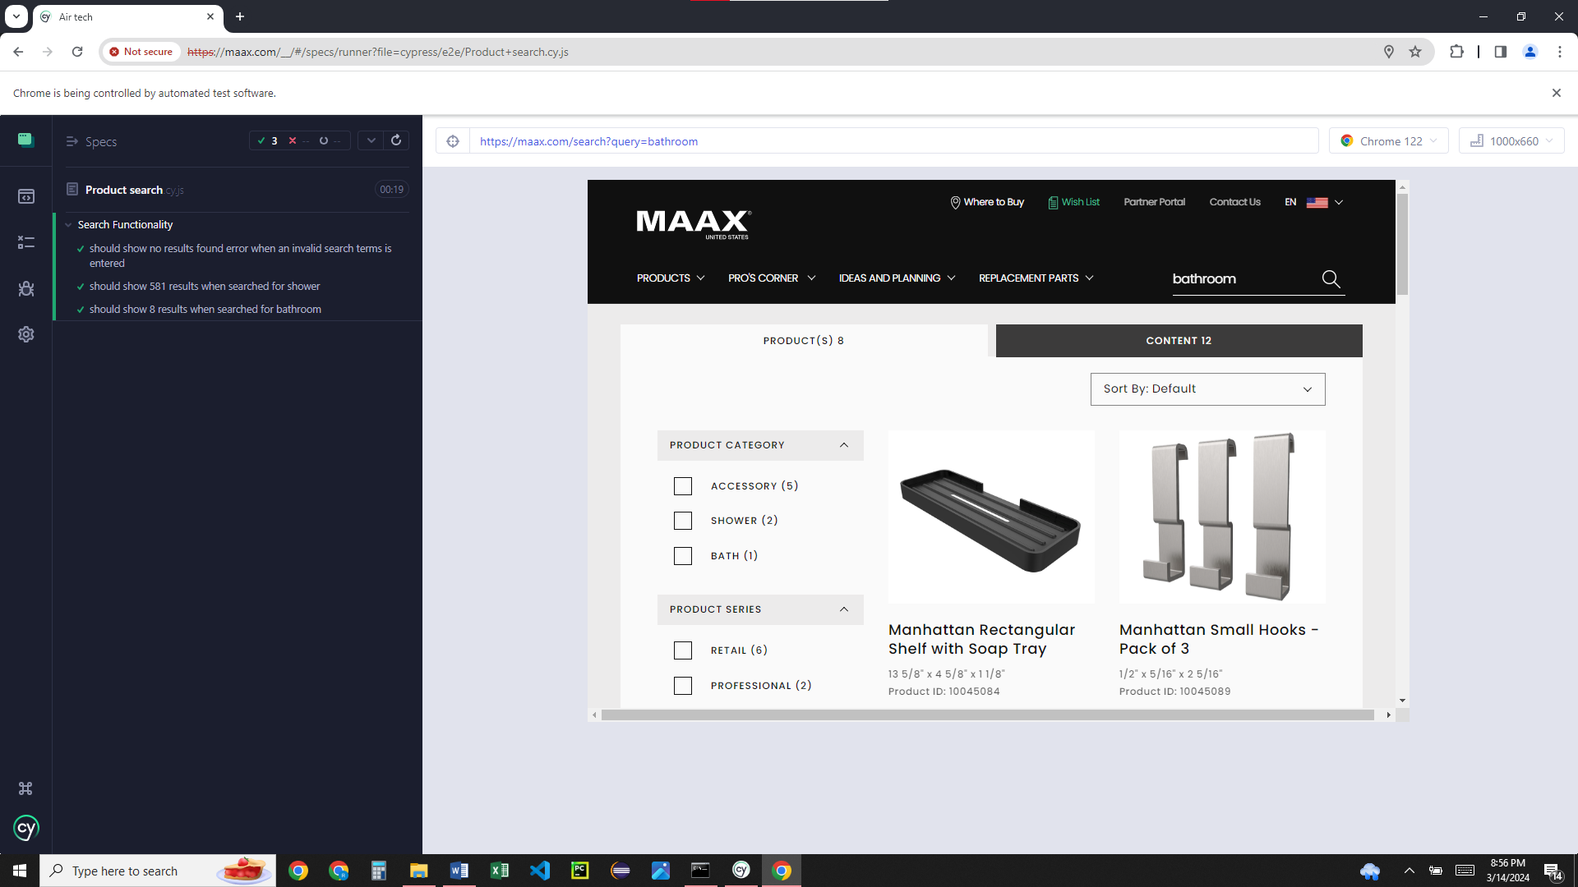

Case 2 – where to buy – Chrome browser

